|  |  |  |  |  |
| --- | --- | --- | --- | --- |
|  |  | | |  |
|  |  | | |  |
|  | Trailer Light Check  <<Feature>>  (F002052) | | |  |
|  |  | | |  |
| Document Type | **Feature Document (FD)** | | |  |
| Template Version | **6.0b / FFSD 8.0** | | |  |
| SysML Report Template Version | **O (11/12/2019)** | | |  |
| Document ID | **F002052** | | |  |
| Document Location | [VSEM Link](https://www.vsemweb.ford.com/tc/launchapp?-attach=true&-s=226TCSession&-o=CKaxDdlMx3NrTDAAAAAAAAAAAAA&servername=Production_Server) | | |  |
| Document Owner | **Andre Batista (abatis38)** | | |  |
| Document Revision | **FD0** | | |  |
| Document Status | **Draft** | | |  |
| Date Issued | **2021-03-23** | | |  |
| Date Revised | **2021-03-23** | | |  |
| Document Classification | GIS1 Item Number: | **27.60/35** | |  |
| GIS2 Classification: | **Confidential** | |
|  | | | | |
|  | | | | |
| Document Approval | | | | |
| Person | Role | | Email Confirmation | Date |
|  |  | |  |  |
|  |  | |  |  |

**Auto-Generated by MagicDraw**

Printed Copies Are Uncontrolled

# Disclaimer

**This document contains Ford Motor Company Confidential information. Disclosure of the information contained in any portion of this document is not permitted without the expressed, written consent of a duly authorized representative of Ford Motor Company, Dearborn, Michigan, U.S.A.**

**Copyright, Ó 2016 Ford Motor Company**

This document contains information developed and accumulated by and for FORD MOTOR COMPANY. As such, it is a proprietary document, which, if disseminated to unauthorized persons, would provide others with restricted information, data, or procedures not otherwise available, exposing the FORD MOTOR COMPANY to potential harm.

Employees and suppliers having custody of this specification or authorized to use it must be cognizant of its proprietary nature and ensure that the information herein is not made available to unauthorized persons.

FORD MOTOR COMPANY reserves the right to protect this work as an unpublished copyrighted work in the event of an inadvertent or deliberate unauthorized publication. FORD MOTOR COMPANY also reserves its rights under copyright laws to protect this work as a published work.

This document or portions thereof shall not be distributed outside FORD MOTOR COMPANY without prior written consent. Refer all questions concerning disclosure to the author(s) or to any duly authorized representative of Ford Motor Company.

# Contents

Disclaimer 2

Contents 3

1 Introduction 5

1.1 Document Purpose 5

1.2 Document Scope 5

1.3 Document Audience 5

1.3.1 Stakeholder List 5

1.4 Document Organization 5

1.4.1 Document Context 5

1.4.2 Document Structure 6

1.5 Document Conventions 6

1.5.1 Requirements Templates 6

1.6 References 6

1.6.1 Ford Documents 6

1.6.2 External Documents and Publications 6

1.7 Glossary 7

1.7.1 Parameters / Values 7

1.7.2 Abbreviations 7

2 Feature Overview 8

2.1 Purpose and Description of Feature 8

2.2 Feature Variants 9

2.2.1 Regions & Markets 9

2.3 Input Requirements 9

2.3.1 Legal Requirements 9

2.3.2 Trustmark Requirements 9

2.3.3 Industry Standards 9

2.3.4 Attribute Requirements 9

2.4 Lessons Learned 9

2.5 Assumptions 10

2.6 Constrains 10

3 Feature Context 11

3.1 Feature Context Diagram 11

3.2 List of Influences 12

4 Feature Modeling 13

4.1 Operation Modes and States 13

4.2 Use Cases 13

4.2.1 Use Case Diagram 13

4.2.2 Actors 14

4.2.3 Use Case Descriptions 14

4.3 Driving and Operation Scenarios 16

4.4 Decision Tables 18

5 Feature Requirements 19

5.1 Functional Requirements 19

5.1.1 Error Handling 21

5.2 Non-Functional Requirements 22

5.2.1 Safety 22

5.2.2 Security 22

5.2.3 Reliability 22

5.3 HMI Requirements 22

5.4 Other Requirements 24

5.4.1 Design Requirements 24

5.4.2 Manufacturing Requirements 24

5.4.3 Service Requirements 24

5.4.4 After Sales Requirements 24

5.4.5 Process Requirements 24

5.4.6 Uncategorized Requirements 24

6 Functional Safety 25

6.1 System Behaviors for HARA 25

6.2 Safety Assumptions 25

6.3 Safety Goals 26

6.4 Functional Safety Requirements 26

6.4.1 Safety Goal: Prevent Hazard (Example) 26

6.4.2 Derivation of Functional Safety Requirements on Assumptions 26

6.5 ASIL Decomposition of Functional Safety Requirements 26

6.5.1 Decomposition of Functional Safety Requirement 26

7 Architecture 27

7.1 Functional Architecture 27

7.1.1 List of Functions 27

7.2 Logical Architecture 28

7.2.1 Logical Elements 28

7.2.2 Logical Interfaces 30

8 Open Concerns 36

9 Revision History 37

10 Appendix 38

10.1 Definitions 38

10.2 Abbreviations 38

**List of Figures**

Figure 1: Trailer Light Check Feature Image 8

Figure 2: Feature Operational Context 11

Figure 3: TLC Logical Operating Modes 13

Figure 4: Trailer Light Check Use Case 14

**Figure 5: P-Diagram** 16

Figure 6: Operation Scenarios 17

Figure 6: Functional Architecture 27

Figure 8: Logical Architecture 28

**List of Tables**

Table 1: Features described in this FD 5

Table 2: Ford internal Documents 6

Table 3: External documents and publications 7

Table 4: Parameters / Values used in this document 7

Table 5: Abbreviations used in this document 7

Table 6: Feature Variants 9

Table 7: Regions & Markets 9

Table 8: List of Influences 12

Table 9: Operation Modes and States on TLC Logical Operating Modes 13

Table 10: Transitions between Operation Modes and States on TLC Logical Operating Modes 13

Table 11: List of Actors 14

Table 12: List of Operation Scenarios 17

Table 13: System Behaviors for HARA 25

Table 14: Functional Safety Assumptions 26

Table 15: List of Functions 27

Table 16: Logical Elements 30

Table 17: Feature Interactions 35

Table 18: Open Concerns 36

Table 19: Revision History 37

Table 20: Definitions used in this document 38

# Introduction

## Document Purpose

A Feature Document (FD) document specifies **what** the feature shall do and how it shall behave from customer perspective. It should also provide reasoning and background **why** we have the feature in the vehicle.

The FD also serves as an Item Definition as defined by ISO26262 for those features, which follow the Ford Functional Safety process.

To get more information about the concept of feature, function and component level abstraction refer to the [Ford RE Wiki](http://wiki.ford.com/display/RequirementsEngineering/Requirements+Engineering+for+SW+Enabled+Features). For details on the Ford Functional Safety (ISO26262) process refer to the [Ford Functional Safety Sharepoint](https://pd3.spt.ford.com/sites/GlobalFunctionalSafety/Pages/default.aspx).

## Document Scope

This Feature Document (FD) specifies the following features:

|  |  |  |  |
| --- | --- | --- | --- |
| **Feature ID** | **Feature Name** | **Owner** | **Reference** |
| F002052 | Trailer Light Check | Andre Batista (abatis38) |  |

Table 1: Features described in this FD

## Document Audience

The FD is written by the feature owner of Andre Batista (abatis38) . All Stakeholders, i.e., all people who have a valid interest in the feature should read and, if possible, review the FD. It needs to be guaranteed, that all stakeholders have access to the currently valid version of the FD.

### Stakeholder List

For the latest list of stakeholder of the feature and their influence refer to [VSEM Link](https://www.vsemweb.ford.com/tc/launchapp?-attach=true&-s=226TCSession&-o=CKaxDdlMx3NrTDAAAAAAAAAAAAA&servername=Production_Server).

## Document Organization

### Document Context

Refer to the [Specification Structure page](http://wiki.ford.com/display/RequirementsEngineering/Specification+templates) in the [Ford RE Wiki](http://wiki.ford.com/display/RequirementsEngineering/Requirements+Engineering+for+SW+Enabled+Features) to understand how the FD relates to other Ford Requirements Documents and Specifications.

### Document Structure

The structure of this document is explained below:

**Section 1** – Introduction how to use this document including responsibilities and requisite documents. Explains the terminology. Gives a clarification of the definitions, concepts and abbreviations used in the document.

**Section 2** – Feature Description. States briefly the background and the purpose of the feature, feature variants and corresponding regions and markets. Also includes input requirements, assumptions and constraints.

**Section 3** – Feature Context describes all external entities, which have an influence on the feature.

**Section 4** – Feature Modeling. Contains Use Case, Driving Scenarios, State Charts to describe the functional behavior of the feature.

**Section 5** – Safety. Lists System Behaviors and Safety Goals of the feature.

**Section 6** – Feature Requirements. Lists functional and non-functional requirements of the feature.

**Section 7** – Architecture. Shows the coarse architecture, which the feature requirements are deployed to. Describes the elements and the boundary of the feature as well as the decomposition and distribution of associated functions.

**Section 8** – List of Open Concerns

**Section 9** – Document Change History including a list of new or modified requirements. The requirements in this document are tagged, and this section contains different types of tables listing all, new, or changed requirements by their title and page no.

**Section 10** – Appendix

## Document Conventions

### Requirements Templates

Each requirement, use case or scenario in this specification shall follow the corresponding template given in the document template *Specification_Macros.dotm* at [RE Wiki - Specification Templates](http://wiki.ford.com/display/RequirementsEngineering/Specification+templates?src=contextnavpagetreemode).

#### Identification of requirements

#### Requirements Attributes

The templates provided by *Specification_Macros.dotm* define a list of attributes for each requirement. This helps to classify the requirement. The attributes are explained at [RE Wiki - Requirements Attributes](http://wiki.ford.com/display/RequirementsEngineering/Requirements+Attributes?src=contextnavpagetreemode).

## References

### Ford Documents

List here all Ford internal documents, which are directly related to the feature.

|  |  |  |  |
| --- | --- | --- | --- |
| **Reference** | **Doc. ID** | **Title** | **Revision** |
| Spec 1 | FS-LU5T-14B476-AAA | Functional Specification Body Control Module |  |
| Spec 2 | DS-MU5T-14B476-AAB001 | Subsystem Specific Diagnostic Specification (Part 2)  Body Control Module |  |
| Spec 3 | DSMU5T-14G650-AAA | ECG Part II Specification |  |
| Spec 4 | 21MY P702 V25 TIB 20 | P702 PDL document |  |

Table 2: Ford internal Documents

### External Documents and Publications

The list of external documents could include books, reports and online sources.

|  |  |  |  |
| --- | --- | --- | --- |
| **Reference** | **Doc. ID** | **Title** | **Revision** |
| 1 | N/A | FMVSS 108 - Lamps, Reflective Devices, And Associated Equipment | N/A |
| 2 | N/A | ECE R/48 Rev6 - Vehicles With Regard To The Installation Of Lighting And Light Signaling Devices | 6 |

Table 3: External documents and publications

## Glossary

See Appendix for Definitions and Abbreviations.

### Parameters / Values

|  |  |
| --- | --- |
| Definition | Description |
| Vehicle Stationary | Vehicle is defined as stationary if vehicle speed is less than 4 KPH and vehicle in in the “Parked State” |
| Parked State | On automatic transmissions, the vehicle PRNDL is in “PARK” and for manual transmissions, the vehicle has the parking brake applied |

Table 4: Parameters / Values used in this document

### Abbreviations

|  |  |  |
| --- | --- | --- |
| Abbr. | Stands for | Description |
| AFS | Aggregated Feature Spec | Type of this document |
| ARL | Attribute Requirements List | Documents vehicle-level characteristics, using RQMTs and DVMs |
| APIM | Application Protocol Interface Module | SYNC user interface to vehicle |
| BCM | Body Control Module | Feature arbitrator |
| CAN | Controller Area Network | Vehicle communication architecture / protocol |
| ECG | Enhanced Central Gateway | Module that diverts CAN traffic through vehicle |
| GWM | Gateway Module | Module that diverts CAN traffic through vehicle |
| LED | Light Emitting Diode | Diode that emits light when voltage is applied to it |
| PDB | Power Distribution box | Box that delivers power to the trailer tail and reverse lights |
| TCU | Telematics Control Unit | Vehicle modem that communicates with cloud/FordPass |
| TTLM | Trailer Tow Light Module | Module that delivers power to the trailer battery, turn lights and brake lights |
| ITRM | Integrated Trailer Module | Module that delivers power to the trailer battery, turn lights and brake lights |
| UI | User Interface | HMI interface to user |
| EOL | End of Line |  |
| CAN | Controller Area Network |  |
| MS1 | Medium Speed 1 | Medium Speed CAN network 1 |
| HS1 | High Speed 1 | High Speed CAN network 1 |
| HS3 | High Speed 3 | High Speed CAN network 3 |
| SOC | State of Charge | Battery State of Charge |
| BT | Bluetooth | SYNC,AppLink - Bluetooth connection for Ford vehicles |

Table 5: Abbreviations used in this document

# Feature Overview

## Purpose and Description of Feature

The Trailer Light Check feature will allow the vehicle user to independently visually check the light operation of a towed trailer. Upon activation of feature through APIM or FordPass the vehicle and trailer lights will illuminate in the sequence described below:

1. Parking lights will turn ON and remain on through test sequences 1-7

2. Wait 2.3* seconds with only parking lights ON

3. Left turn light on vehicle and trailer will flash on and off 6* times

4. Right turn light on vehicle and trailer will flash on and off 6* times

5. Brake lights on vehicle and trailer will turn ON for 4.5* seconds

6. Reverse lights on vehicle and trailer will turn ON for 4.5* seconds

7. Fog Lights** on vehicle and trailer will turn ON for 4.5* seconds

8. Wait 2.3* seconds with only parking lights ON

9. Turn off all parking lights*** and wait 2.3* seconds

10. Repeat steps 1-8 for 5* times or until user exits out

* Duration for each step shall be individually calibratable in addition to number of sequence repetitions

**Step 7 is applicable only to ECE vehicles

*** If parking lights have been turned on through hard switch in vehicle, parking lights shall remain on during this step.

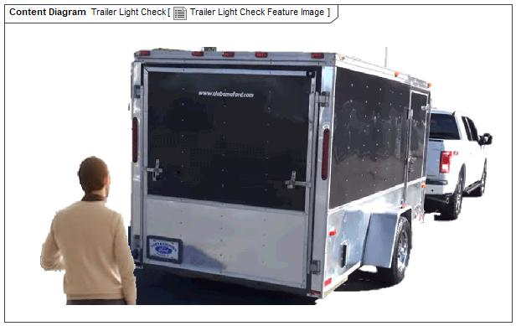

Figure 1: Trailer Light Check Feature Image

## Feature Variants

|  |  |  |
| --- | --- | --- |
| **Variant Name** | **Variant Description** | **Remarks** |
| **-ECE Homologated markets** | ECE R/48 – only Eu market | Included Foglamps |
| **-FNA** | FMVSS-108 | With ITRM/TRM |
| **-FNA less ITRM** | FMVSS-108 | With PDB |

Table 6: Feature Variants

### Regions & Markets

|  |  |  |  |  |  |  |
| --- | --- | --- | --- | --- | --- | --- |
| **Market /**  **Region**  Variant Name | **North America** | **South America** | **Europe** | **MiddleEast/Africa** | **Asia / Pacific** | **China** |
|  | All FMVSS-108 compliant regions only. | All FMVSS-108 compliant regions only. | ECE R/48 Rev. 6 | ECE R/48 Rev. 6 | ECE R/48 Rev. 6 | N/A |

Table 7: Regions & Markets

## Input Requirements

### Legal Requirements

* : Compliance with FMVSS101
  + The Feature shall comply with FMVSS101.
* : Compliance with FMVSS-108
  + The Feature shall comply with FMVSS108.
* : ECE R/48 Rev.6
  + The Feature shall comply with ECE R/48 Rev.6

### Trustmark Requirements

* : FAP03-150

The Feature shall comply with FAP03-150

### Industry Standards

* : IS Compliance with FMVSS-108
  + The Feature shall comply with FMVSS108.
* : IS ECE R/48 Rev.6
  + The Feature shall comply with ECE R/48 Rev.6
* : ISO 26262
  + The system should be developed according to Ford's implementation of Functional Safety.

### Attribute Requirements

* Proj-AR:14 : Example AR
* 14 : Example AR

## Lessons Learned

1. Global requirements such as rear fog lights should be considered when developing a feature.

## Assumptions

Assumptions and constraints listed below are representative of current strategies and may be subject to change:

* The trailer light function feature will utilize existing hardware on the vehicle, no new hardware will be required
* Vehicle is at a minimum FNV2 or later architecture
* Vehicle has Ford factory/dealer installed trailer wiring, hitch and TRM/ iTRM.
* When any action button command comes from in-vehicle HMI, the request shall be processed instantaneously
* When any action button command comes from remote Applink, the request shall be processed within 5 seconds
* When any action button command comes from remote app cellular connection, the request shall be processed within 25 seconds

## Constrains

* Battery SOC level with battery not supported (engine off)
* Vehicle ignition state
* Vehicle stationary status
* Attached trailer with lights
* Manual transmission with electronic park brake.
* Status of other features that affect exterior lighting
* Available pairing options with smartphone (BT, USB, Cellular)

# Feature Context

## Feature Context Diagram

**

Figure 2: Feature Operational Context

## List of Influences

|  |  |  |
| --- | --- | --- |
| **ID** | **External Entity** | **Influence Description** |
| I1 | User | User requests to activate Trailer Light Check |
| I2 | Host Vehicle | Host vehicle HMI to interact with Trailer Light Check |
| I3 | Exterior Lights | Trailer Light Check feature interaction with exterior lights (turning lights ON) |
| I4 | Trailer | Trailer Light Check feature interaction with trailer |
| I5 | Regulations | Need compliance to FMVSS-108 or ECE R/48 Rev. 6,  ISO26262 |
| I6 | FordPass | Remote HMI to interact with Trailer Light Check |

Table 8: List of Influences

# Feature Modeling

## Operation Modes and States



Figure 3: TLC Logical Operating Modes

|  |  |  |
| --- | --- | --- |
| **State** | **Description** | **Requirements Reference** (optional) |
| S1 | Feature is idle |  |
| S2 | Feature is available and in operation |  |

Table 9: Operation Modes and States on TLC Logical Operating Modes

|  |  |  |  |
| --- | --- | --- | --- |
| **Transition ID** | **Description** | **Action** | **Requirements Reference** (optional) |
| <T1> | User requests to initiate Trailer Light Check and pre-conditions are met | <S1> to <S2> |  |
| <T2> | User requests to end Trailer Light Check, test ends normally, or pre-conditions are not met | <S2> to <S1> |  |

Table 10: Transitions between Operation Modes and States on TLC Logical Operating Modes

## Use Cases

### Use Case Diagram

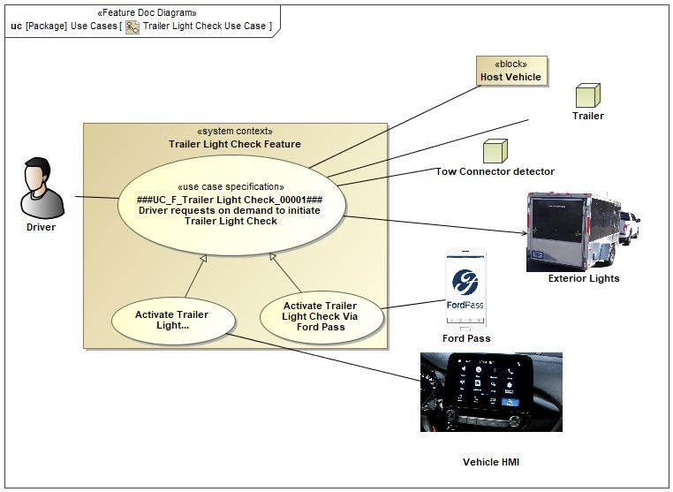

Figure 4: Trailer Light Check Use Case

### Actors

| **Actor** | **Description** |
| --- | --- |
| User | Driver or passenger(s) who own/use the vehicle |
| Exterior Lights | Trailer Light Check feature interaction with exterior lights (turning lights ON/OFF) |
| Ford Pass | App that available connectivity btw vehicle and smartphone |
| Host Vehicle | Host vehicle HMI to interact with Trailer Light Check |
| Tow Connector detector | Connector of tow |
| Trailer | Trailer Light Check feature interaction with trailer |
| Vehicle HMI | Human Machine Intarface |

Table 11: List of Actors

### Use Case Descriptions

###UC_F_Trailer Light Check_00001### User requests on demand to initiate Trailer Light Check via FordPass HMI

|  |  |  |
| --- | --- | --- |
| **Purpose** |  | User requests on demand to initiate Trailer Light Check via FordPass HMI |
| **Actors** |  | User |
| **Precondition** |  | Vehicle has factory or dealer installed trailer wiring  Trailer is connected to the Vehicle  Vehicle battery is >= 75% state of charge with engine off  Ignition is ON or ACC  Vehicle is stationary  Rear Fog lights are not turned on (*only for vehicles in ECE homologated markets*) |
|  |  |  |
| **Main Flow** | M1 | User selects begin test button to activate Trailer Light Check using FordPass HMI |
|  | M2 | User waits for exterior lights to illuminate and turn off on vehicle and trailer |
|  | M3 | User waits for visual confirmation on the feature UI that test has ended |
|  | M4 | User selects “YES” to end of test question (to indicate that lights behaved as expected) |
| **Alternative Flow 1** | A1 | * User can stop test at any when it is running * Feature informs the user that test has been aborted |
|  |  |  |
| **Alternative Flow 2** | A2 | * User runs test (refer to Main Flow) * User selects “NO” to end of test question (i.e., lights did not behave as expected). * Feature displays Troubleshooting screen |
|  |  |  |
| **Post-condition** |  | Light test sequence has ended  User receives a visual confirmation |

###UC_F_Trailer Light Check_00002### User requests on demand to initiate Trailer Light Check via SYNC HMI

|  |  |  |
| --- | --- | --- |
| **Purpose** |  | User requests on demand to initiate Trailer Light Check via SYNC HMI |
| **Actors** |  | User |
| **Precondition** |  | Vehicle has factory or dealer installed trailer wiring  Trailer is connected to the Vehicle  Vehicle battery is >= 75% state of charge with engine off  Ignition is ON or ACC  Vehicle is stationary  Rear Fog lights are not turned on (*only for vehicles in ECE homologated markets*) |
|  |  |  |
| **Main Flow** | M1 | User selects begin test button to activate Trailer Light Check using SYNC HMI |
|  | M2 | User waits for exterior lights to illuminate and turn off on vehicle and trailer |
|  | M3 | User waits for visual confirmation on the feature UI that test has ended |
|  | M4 | User selects “YES” to end of test question (to indicate that lights behaved as expected) |
| **Alternative Flow 1** | A1 | * User can stop test at any when it is running * Feature informs the user that test has been aborted |
|  |  |  |
| **Alternative Flow 2** | A2 | * User runs test (refer to Main Flow) * User selects “NO” to end of test question (i.e., lights did not behave as expected). * Feature displays Troubleshooting screen |
|  |  |  |
| **Post-condition** |  | Light test sequence has ended  User receives a visual confirmation |

## Driving and Operation Scenarios

Driving Scenarios

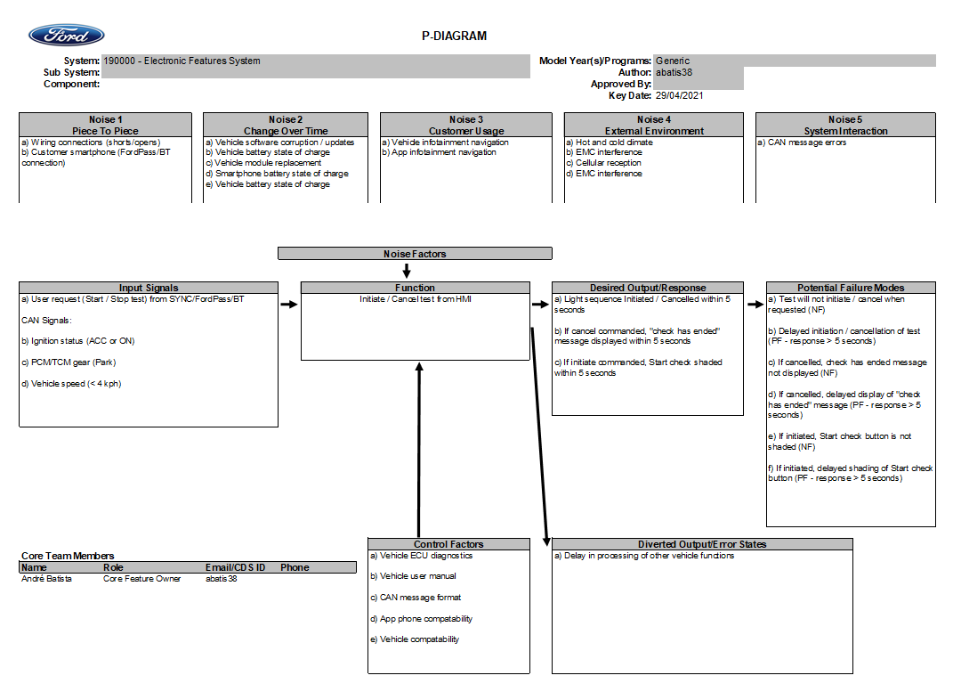Driving Scenarios can be represented by P-Diagram and also for FMEA [FMEA_Link](https://www.fedewb.ford.com/#/system-viewer/fma?uid=XFV5sXDLoPHwuB&s_cpsc=Trailer%20Light%20Check&rr=P708_2023.00_J1_Published&prog=P708%20PROGRAM%20NODE&s_tab=Program&s_activity=FMA&br_params=FEDE%20STRUCTURE~a0WpoTbDBhGXHA:EjT1nWFPBhGXHA%7CPMT~a0WpoTbDBhGXHA:EjT1nWFPBhGXHA:Ead1oQJ8oPHwuB%7CPMT500%20-%20Electrical~a0WpoTbDBhGXHA:EjT1nWFPBhGXHA:Ead1oQJ8oPHwuB:qBU13zmzoPHwuB%7C190000%20-%20Electronic%20Features%20System_2023~a0WpoTbDBhGXHA:EjT1nWFPBhGXHA:Ead1oQJ8oPHwuB:qBU13zmzoPHwuB:qbV13zpSoPHwuB%7CTrailer%20Light%20Check~a0WpoTbDBhGXHA:EjT1nWFPBhGXHA:Ead1oQJ8oPHwuB:qBU13zmzoPHwuB:qbV13zpSoPHwuB:XeX5sXDLoPHwuB&p_type=SOIL&itemPrg=a4cpoTbDBhGXHA&rr_uid=kVb13mufoPHwuB&ptnr_uid=1&stableIdChain=a0WpoTbDBhGXHA:EjT1nWFPBhGXHA:Ead1oQJ8oPHwuB:qBU13zmzoPHwuB:qbV13zpSoPHwuB:XeX5sXDLoPHwuB&pcode=P149&cacheContext=RSb9lUeqoPHwuB&vr=All_Content&vr_uid=QgQ1nWskBhGXHA%0A).

**Figure 5: P-Diagram**

Operation Scenarios

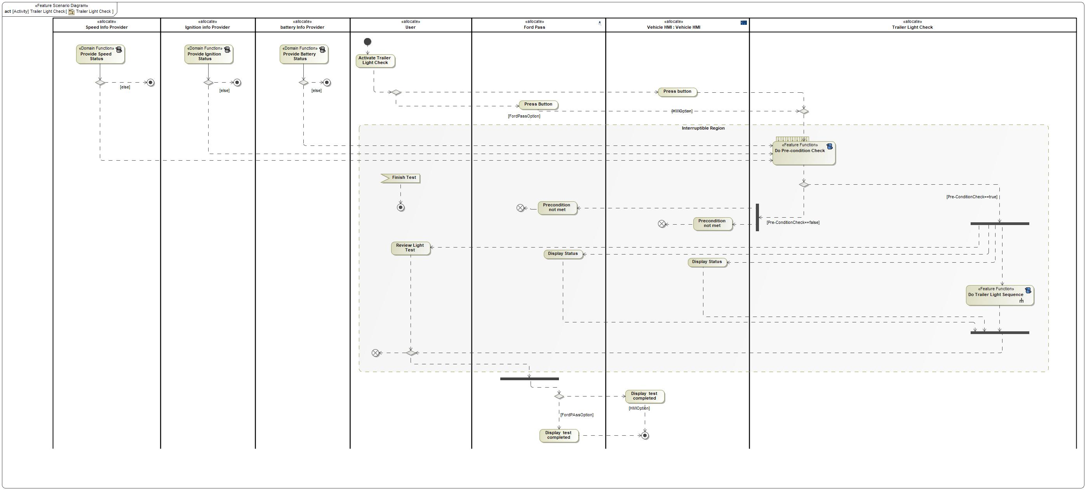

Figure 6: Operation Scenarios

|  |  |
| --- | --- |
| **Flow of Operation Scenarios** | |
| 1 | User activate Trailer Light Check |
| 2 | Provide Speed Status |
| 3 | Provide Ignition Status |
| 4 | Provide Battery Status |
| 5 | System detects Pre-Condictions Status |
| 6 | Trailer Ligh Check Sequence starts |
| 7 | Display Test Results |

Table 12: List of Operation Scenarios

## Decision Tables

Not applicable.

# Feature Requirements

## Functional Requirements

00001 ###R_F_Trailer Light Check_00001### Feature Start / Stop

Trailer Light Check feature shall enable the user to Start or Stop the Trailer Light Check by pressing a control element.

|  |  |  |  |  |  |  |  |
| --- | --- | --- | --- | --- | --- | --- | --- |
| Requirement ID: 00001 | | | | | | | |
| **Rationale** | To activate/deactivate the feature operation | | | | | | |
| **Acceptance Criteria** | Meet | | | | | | |
| **Notes** | N/A | | | | | | |
| **Source** | HMI owners | | | | | **Owner** | abatis38 |
| **Source Req.** | [VSEM Link](https://www.vsemweb.ford.com/tc/launchapp?-attach=true&-s=226TCSession&-o=CKaxDdlMx3NrTDAAAAAAAAAAAAA&servername=Production_Server) | | | | | **V&V Method** | Verify by [VSEM_Link](https://www.vsemweb.ford.com/tc/launchapp?-attach=true&-s=226TCSession&-o=CKaxDdlMx3NrTD&servername=Production_Server) |
| **Type** | Functional | | | **Priority** | 1 - High | **Status** | Approved |
| [Req. Template](http://wiki.ford.com/display/RequirementsEngineering/Requirements+Attributes) Version | | 6.0 | End of Requirement | | | | |

00002 ###R_F_Trailer Light Check_00002### Feature operation

Upon selection of Trailer Light Check Feature Start button and all preconditions are met, the vehicle and trailer lights shall exhibit the below behavior:

1. Tail lights (including front and rear side markers) will turn ON and remain on through test sequences 1-7

1.1 Turn on license plate lights.

1. Wait 2.3* seconds with only tail lights ON (including front and rear side markers)
2. Left turn light on vehicle and trailer will flash on and off 6* times
3. Right turn light on vehicle and trailer will flash on and off 6* times
4. Brake lights on vehicle and trailer will turn ON for 4.5* seconds
5. Reverse lights on vehicle and trailer will turn ON for 4.5* seconds**
6. Rear Fog Lights on trailer will turn ON for 4.5* seconds***
7. Wait 2.3* seconds with only tail lights ON (including front and rear side markers)
8. Turn off all tail lights (including front and rear side markers)****

9.1 Turn off license plate lights

9.2 Wait 2.3 seconds*

1. Repeat steps 1-8 for 5* times or until user exits out

*\* Duration for each step shall be individually calibratable in addition to number of sequence repetitions.*

*\*\* If reverse lights are ON prior to entering step 6, this step shall be skipped.*

*\*\*\*Step 7 is applicable only to vehicles in ECE homologated markets, in ECE homologated markets, the vehicle rear fog light will not be lit if the trailer is connected.*

*\*\*\*\* If tail lights have been turned on through hard switch in vehicle, tail lights shall remain on during this step.*

|  |  |  |  |  |  |  |  |
| --- | --- | --- | --- | --- | --- | --- | --- |
| Requirement ID: 00002 | | | | | | | |
| **Rationale** | Show preconditions for user in order to instruct start Trailer Light Check | | | | | | |
| **Acceptance Criteria** | Meet | | | | | | |
| **Notes** | N/A | | | | | | |
| **Source** | ECU owners | | | | | **Owner** | abatis38 |
| **Source Req.** | [VSEM Link](https://www.vsemweb.ford.com/tc/launchapp?-attach=true&-s=226TCSession&-o=CKaxDdlMx3NrTDAAAAAAAAAAAAA&servername=Production_Server) | | | | | **V&V Method** | Verify by [VSEM_Link](https://www.vsemweb.ford.com/tc/launchapp?-attach=true&-s=226TCSession&-o=CKaxDdlMx3NrTD&servername=Production_Server) |
| **Type** | HMI Requirement | | | **Priority** | 2 - Medium | **Status** | Approved |
| [Req. Template](http://wiki.ford.com/display/RequirementsEngineering/Requirements+Attributes) Version | | 6.0 | End of Requirement | | | | |

00003 ###R_F_Trailer Light Check_00003### Vehicle stationary status (Automatic transmission vehicles only)

For Trailer Light Check Feature, vehicle shall be defined as stationary if gearshift position is in park and vehicle speed less than or equal to 4 KPH (automatic transmission vehicles only).

|  |  |  |  |  |  |  |  |
| --- | --- | --- | --- | --- | --- | --- | --- |
| Requirement ID: 00003 | | | | | | | |
| **Rationale** | Speed restriction in order to guarantee the vehicle is in stationary status | | | | | | |
| **Acceptance Criteria** | Meet | | | | | | |
| **Notes** | N/A | | | | | | |
| **Source** | ECU owners | | | | | **Owner** | abatis38 |
| **Source Req.** | [VSEM Link](https://www.vsemweb.ford.com/tc/launchapp?-attach=true&-s=226TCSession&-o=CKaxDdlMx3NrTDAAAAAAAAAAAAA&servername=Production_Server) | | | | | **V&V Method** | Verify by [VSEM_Link](https://www.vsemweb.ford.com/tc/launchapp?-attach=true&-s=226TCSession&-o=CKaxDdlMx3NrTD&servername=Production_Server) |
| **Type** | Functional | | | **Priority** | 2 - Medium | **Status** | Approved |
| [Req. Template](http://wiki.ford.com/display/RequirementsEngineering/Requirements+Attributes) Version | | 6.0 | End of Requirement | | | | |

00004 ###R_F_Trailer Light Check_00004### Vehicle stationary status (Manual transmission vehicles only)

For Trailer Light Check Feature, vehicle shall be defined as stationary if electric parking brake is applied and vehicle speed is less than or equal to 4 KPH (manual transmission vehicles only).

|  |  |  |  |  |  |  |  |
| --- | --- | --- | --- | --- | --- | --- | --- |
| Requirement ID: 00004 | | | | | | | |
| **Rationale** | Speed restriction in order to guarantee the vehicle is in stationary status | | | | | | |
| **Acceptance Criteria** | Meet | | | | | | |
| **Notes** | N/A | | | | | | |
| **Source** | ECU owners | | | | | **Owner** | abatis38 |
| **Source Req.** | [VSEM Link](https://www.vsemweb.ford.com/tc/launchapp?-attach=true&-s=226TCSession&-o=CKaxDdlMx3NrTDAAAAAAAAAAAAA&servername=Production_Server) | | | | | **V&V Method** | Verify by [VSEM_Link](https://www.vsemweb.ford.com/tc/launchapp?-attach=true&-s=226TCSession&-o=CKaxDdlMx3NrTD&servername=Production_Server) |
| **Type** | Functional | | | **Priority** | 2 - Medium | **Status** | Approved |
| [Req. Template](http://wiki.ford.com/display/RequirementsEngineering/Requirements+Attributes) Version | | 6.0 | End of Requirement | | | | |

00005 ###R_F_Trailer Light Check_00005### Feature Pre-Conditions

The Trailer Light Check feature shall not allow the user to activate test and shall exit test if it has already begun if any of the below pre-conditions are not met:

• Ignition is in ON or ACC state

• Battery SOC >= 75% with engine off

• Vehicle is stationary

• Trailer connection to vehicle

• All taillights are OFF (except parking lights) unless demanded by Trailer Light Check

• Other higher priority features that impact external vehicle lighting are not ON (i.e. Police Dark Car, Silent Car, RePA etc.)

*Note: Trailer Connection as a precondition for TLC is not required for P702/P703/U704 MY21 at JOB 1.*

|  |  |  |  |  |  |  |  |
| --- | --- | --- | --- | --- | --- | --- | --- |
| Requirement ID: 00005 | | | | | | | |
| **Rationale** | Show preconditions for user in order to instruct start Trailer Light Check | | | | | | |
| **Acceptance Criteria** | Meet | | | | | | |
| **Notes** | N/A | | | | | | |
| **Source** | ECU and HMI owners | | | | | **Owner** | abatis38 |
| **Source Req.** | [VSEM Link](https://www.vsemweb.ford.com/tc/launchapp?-attach=true&-s=226TCSession&-o=CKaxDdlMx3NrTDAAAAAAAAAAAAA&servername=Production_Server) | | | | | **V&V Method** | Verify by [VSEM_Link](https://www.vsemweb.ford.com/tc/launchapp?-attach=true&-s=226TCSession&-o=CKaxDdlMx3NrTD&servername=Production_Server) |
| **Type** | Functional | | | **Priority** | 1 - High | **Status** | Approved |
| [Req. Template](http://wiki.ford.com/display/RequirementsEngineering/Requirements+Attributes) Version | | 6.0 | End of Requirement | | | | |

00006 ###R_F_Trailer Light Check_00006### Feature feedback on change in pre-condition status

The Trailer Light Check feature shall indicate to the user when the test ends due to a change in feature pre-conditions:

1. Ignition is not in ON or ACC state

2. Engine start required

3. Vehicle is not stationary

4. Trailer is not electrically connected

5. Request for other higher priority feature active

6. Any other Trailer Light Check fault/error

*Note: Trailer Connection as a precondition for TLC is not required for P702/P703/U704 MY21 at JOB 1.*

|  |  |  |  |  |  |  |  |
| --- | --- | --- | --- | --- | --- | --- | --- |
| Requirement ID: 00006 | | | | | | | |
| **Rationale** | HMI shall indicate to the user the specific precondition that was not met | | | | | | |
| **Acceptance Criteria** | Meet | | | | | | |
| **Notes** | N/A | | | | | | |
| **Source** | HMI owners | | | | | **Owner** | abatis38 |
| **Source Req.** | [VSEM Link](https://www.vsemweb.ford.com/tc/launchapp?-attach=true&-s=226TCSession&-o=CKaxDdlMx3NrTDAAAAAAAAAAAAA&servername=Production_Server) | | | | | **V&V Method** | Verify by [VSEM_Link](https://www.vsemweb.ford.com/tc/launchapp?-attach=true&-s=226TCSession&-o=CKaxDdlMx3NrTD&servername=Production_Server) |
| **Type** | HMI Requirement | | | **Priority** | 1 - High | **Status** | Approved |
| [Req. Template](http://wiki.ford.com/display/RequirementsEngineering/Requirements+Attributes) Version | | 6.0 | End of Requirement | | | | |

00007 ###R_F_Trailer Light Check_00007### Feature behavior with multiple Start commands

Once Trailer Light Check feature has been initiated, the feature shall ignore any additional lower priority feature start commands

|  |  |  |  |  |  |  |  |
| --- | --- | --- | --- | --- | --- | --- | --- |
| Requirement ID: 00007 | | | | | | | |
| **Rationale** | HMI shall indicate TLC operation | | | | | | |
| **Acceptance Criteria** | Meet | | | | | | |
| **Notes** | As HMI shall indicate TLC operation is not able to show other commands until deactivate the operation. | | | | | | |
| **Source** | HMI owners | | | | | **Owner** | abatis38 |
| **Source Req.** | [VSEM Link](https://www.vsemweb.ford.com/tc/launchapp?-attach=true&-s=226TCSession&-o=CKaxDdlMx3NrTDAAAAAAAAAAAAA&servername=Production_Server) | | | | | **V&V Method** | Verify by [VSEM_Link](https://www.vsemweb.ford.com/tc/launchapp?-attach=true&-s=226TCSession&-o=CKaxDdlMx3NrTD&servername=Production_Server) |
| **Type** | HMI Requirement | | | **Priority** | 2 - Medium | **Status** | Approved |
| [Req. Template](http://wiki.ford.com/display/RequirementsEngineering/Requirements+Attributes) Version | | 6.0 | End of Requirement | | | | |

00008 ###R_F_Trailer Light Check_00008### Feature behavior with reverse light

Once Trailer Light Check feature has been initiated, the activity of this feature shall skip the reverse light check if reverse lights are ON before entering the sequence.

|  |  |  |  |  |  |  |  |
| --- | --- | --- | --- | --- | --- | --- | --- |
| Requirement ID: 00008 | | | | | | | |
| **Rationale** | TLC shall skip the reverse light check if the reverse lights are on before start sequence | | | | | | |
| **Acceptance Criteria** | Meet | | | | | | |
| **Notes** | N/A | | | | | | |
| **Source** | ECU owners | | | | | **Owner** | abatis38 |
| **Source Req.** | [VSEM Link](https://www.vsemweb.ford.com/tc/launchapp?-attach=true&-s=226TCSession&-o=CKaxDdlMx3NrTDAAAAAAAAAAAAA&servername=Production_Server) | | | | | **V&V Method** | Verify by [VSEM_Link](https://www.vsemweb.ford.com/tc/launchapp?-attach=true&-s=226TCSession&-o=CKaxDdlMx3NrTD&servername=Production_Server) |
| **Type** | Functional | | | **Priority** | 1 - High | **Status** | Approved |
| [Req. Template](http://wiki.ford.com/display/RequirementsEngineering/Requirements+Attributes) Version | | 6.0 | End of Requirement | | | | |

00009 ###R_F_Trailer Light Check_00009### Feature turn signal behavior

When the Trailer Light Check feature is testing turn signal function, the feature shall turn on and turn off the turn signals at the same rate the vehicle would normally flash the signals had they been commanded manually

|  |  |  |  |  |  |  |  |
| --- | --- | --- | --- | --- | --- | --- | --- |
| Requirement ID: 00009 | | | | | | | |
| **Rationale** | How the TLC works | | | | | | |
| **Acceptance Criteria** | Meet | | | | | | |
| **Notes** | N/A | | | | | | |
| **Source** | ECU owners | | | | | **Owner** | abatis38 |
| **Source Req.** | [VSEM Link](https://www.vsemweb.ford.com/tc/launchapp?-attach=true&-s=226TCSession&-o=CKaxDdlMx3NrTDAAAAAAAAAAAAA&servername=Production_Server) | | | | | **V&V Method** | Verify by [VSEM_Link](https://www.vsemweb.ford.com/tc/launchapp?-attach=true&-s=226TCSession&-o=CKaxDdlMx3NrTD&servername=Production_Server) |
| **Type** | Functional | | | **Priority** | 1 - High | **Status** | Approved |
| [Req. Template](http://wiki.ford.com/display/RequirementsEngineering/Requirements+Attributes) Version | | 6.0 | End of Requirement | | | | |

### Error Handling

00010 ###R_F_Trailer Light Check_00010### Remote device out of cellular range

When remote app hosting device goes out of cellular range after Trailer Light Check feature has been initiated, the Trailer Light Check shall continue with normal test operation.

|  |  |  |  |  |  |  |  |
| --- | --- | --- | --- | --- | --- | --- | --- |
| Requirement ID: 00010 | | | | | | | |
| **Rationale** | Customer activates via FordPass on cell Phone TLC sequence in range of bluetooth connection or internet | | | | | | |
| **Acceptance Criteria** | Meet | | | | | | |
| **Notes** | Customer is not informed about exceeding distance | | | | | | |
| **Source** | ECU owners | | | | | **Owner** | abatis38 |
| **Source Req.** | [VSEM Link](https://www.vsemweb.ford.com/tc/launchapp?-attach=true&-s=226TCSession&-o=CKaxDdlMx3NrTDAAAAAAAAAAAAA&servername=Production_Server) | | | | | **V&V Method** | Verify by [VSEM_Link](https://www.vsemweb.ford.com/tc/launchapp?-attach=true&-s=226TCSession&-o=CKaxDdlMx3NrTD&servername=Production_Server) |
| **Type** | Functional | | | **Priority** | 3 - Low | **Status** | Approved |
| [Req. Template](http://wiki.ford.com/display/RequirementsEngineering/Requirements+Attributes) Version | | 6.0 | End of Requirement | | | | |

00011 ###R_F_Trailer Light Check_00011### Trailer Connection Checking

When the trailer is electrically disconnected after Trailer Light Check feature has been initiated, the user will notify the signal in the HMI

|  |  |  |  |  |  |  |  |
| --- | --- | --- | --- | --- | --- | --- | --- |
| Requirement ID: 00011 | | | | | | | |
| **Rationale** | HMI shall display the popup with the information regarding trailer disconnected | | | | | | |
| **Acceptance Criteria** | Meet | | | | | | |
| **Notes** | N/A | | | | | | |
| **Source** | HMI owners | | | | | **Owner** | abatis38 |
| **Source Req.** | [VSEM Link](https://www.vsemweb.ford.com/tc/launchapp?-attach=true&-s=226TCSession&-o=CKaxDdlMx3NrTDAAAAAAAAAAAAA&servername=Production_Server) | | | | | **V&V Method** | Verify by [VSEM_Link](https://www.vsemweb.ford.com/tc/launchapp?-attach=true&-s=226TCSession&-o=CKaxDdlMx3NrTD&servername=Production_Server) |
| **Type** | Functional | | | **Priority** | 1 - High | **Status** | Approved |
| [Req. Template](http://wiki.ford.com/display/RequirementsEngineering/Requirements+Attributes) Version | | 6.0 | End of Requirement | | | | |

## Non-Functional Requirements

### Safety

### Security

### Reliability

## HMI Requirements

00012 ###R_F_Trailer Light Check_00013### Feature UI

The Trailer Light Check feature shall have a dedicated user interface screen on the in-vehicle and remote app displays

|  |  |  |  |  |  |  |  |
| --- | --- | --- | --- | --- | --- | --- | --- |
| Requirement ID: 00012 | | | | | | | |
| **Rationale** | HMI shall have a dedicated screen for TLC | | | | | | |
| **Acceptance Criteria** | Meet | | | | | | |
| **Notes** | N/A | | | | | | |
| **Source** | HMI owners | | | | | **Owner** | abatis38 |
| **Source Req.** | [VSEM Link](https://www.vsemweb.ford.com/tc/launchapp?-attach=true&-s=226TCSession&-o=CKaxDdlMx3NrTDAAAAAAAAAAAAA&servername=Production_Server) | | | | | **V&V Method** | Verify by [VSEM_Link](https://www.vsemweb.ford.com/tc/launchapp?-attach=true&-s=226TCSession&-o=CKaxDdlMx3NrTD&servername=Production_Server) |
| **Type** | HMI Requirement | | | **Priority** | 2 - Medium | **Status** | Approved |
| [Req. Template](http://wiki.ford.com/display/RequirementsEngineering/Requirements+Attributes) Version | | 6.0 | End of Requirement | | | | |

00013 ###R_F_Trailer Light Check_00014### Feature feedback upon pre-condition violation

When the user selects start test and pre-conditions are not met, HMI feedback shall display the pre-condition that was not met:

1. Ignition is not in ON or ACC state

2. Engine start required

3.Trailer is not connected

4. Vehicle is not stationary

5. Vehicle is not in Park (P)

6. Other higher priority features interaction

*Note: Trailer Connection as a precondition for TLC is not required for P702/P703/U704 MY21 at JOB 1.*

|  |  |  |  |  |  |  |  |
| --- | --- | --- | --- | --- | --- | --- | --- |
| Requirement ID: 00013 | | | | | | | |
| **Rationale** | HMI shall indicate to the user the specific precondition that was not met | | | | | | |
| **Acceptance Criteria** | Meet | | | | | | |
| **Notes** | N/A | | | | | | |
| **Source** | HMI owners | | | | | **Owner** | abatis38 |
| **Source Req.** | [VSEM Link](https://www.vsemweb.ford.com/tc/launchapp?-attach=true&-s=226TCSession&-o=CKaxDdlMx3NrTDAAAAAAAAAAAAA&servername=Production_Server) | | | | | **V&V Method** | Verify by [VSEM_Link](https://www.vsemweb.ford.com/tc/launchapp?-attach=true&-s=226TCSession&-o=CKaxDdlMx3NrTD&servername=Production_Server) |
| **Type** | Functional | | | **Priority** | 1 - High | **Status** | Approved |
| [Req. Template](http://wiki.ford.com/display/RequirementsEngineering/Requirements+Attributes) Version | | 6.0 | End of Requirement | | | | |

00014 ###R_F_Trailer Light Check_00015### Feature feedback upon Start/Stop command

When the user presses the Trailer Light Check feature Start or Stop control element on in-vehicle UI or remote app, HMI shall behave as follows:

1. Upon a valid Start test command, the Start test control element will no longer be selectable and Stop test control element will be selectable

2. Upon a valid Stop test command, the Stop test control element will no longer be selectable and Start test control element will be selectable

|  |  |  |  |  |  |  |  |
| --- | --- | --- | --- | --- | --- | --- | --- |
| Requirement ID: 00014 | | | | | | | |
| **Rationale** | HMI shall interchange between start and stop button | | | | | | |
| **Acceptance Criteria** | Meet | | | | | | |
| **Notes** | N/A | | | | | | |
| **Source** | HMI owners | | | | | **Owner** | abatis38 |
| **Source Req.** | [VSEM Link](https://www.vsemweb.ford.com/tc/launchapp?-attach=true&-s=226TCSession&-o=CKaxDdlMx3NrTDAAAAAAAAAAAAA&servername=Production_Server) | | | | | **V&V Method** | Verify by [VSEM_Link](https://www.vsemweb.ford.com/tc/launchapp?-attach=true&-s=226TCSession&-o=CKaxDdlMx3NrTD&servername=Production_Server) |
| **Type** | Functional | | | **Priority** | 1 - High | **Status** | Approved |
| [Req. Template](http://wiki.ford.com/display/RequirementsEngineering/Requirements+Attributes) Version | | 6.0 | End of Requirement | | | | |

00015 ###R_F_Trailer Light Check_00016### Feature feedback upon pre-condition

When the user selects start test and pre-conditions are not met, HMI feedback shall display the pre-condition that was not met:

|  |  |  |  |  |  |  |  |
| --- | --- | --- | --- | --- | --- | --- | --- |
| Requirement ID: 00015 | | | | | | | |
| **Rationale** | HMI shall indicate to the user the specific precondition that was not met | | | | | | |
| **Acceptance Criteria** | Meet | | | | | | |
| **Notes** | N/A | | | | | | |
| **Source** | HMI owners | | | | | **Owner** | abatis38 |
| **Source Req.** | [VSEM Link](https://www.vsemweb.ford.com/tc/launchapp?-attach=true&-s=226TCSession&-o=CKaxDdlMx3NrTDAAAAAAAAAAAAA&servername=Production_Server) | | | | | **V&V Method** | Verify by [VSEM_Link](https://www.vsemweb.ford.com/tc/launchapp?-attach=true&-s=226TCSession&-o=CKaxDdlMx3NrTD&servername=Production_Server) |
| **Type** | HMI Requirement | | | **Priority** | 2 - Medium | **Status** | Approved |
| [Req. Template](http://wiki.ford.com/display/RequirementsEngineering/Requirements+Attributes) Version | | 6.0 | End of Requirement | | | | |

00016 ###R_F_Trailer Light Check_00017### Trailer not Connected

When the trailer is electrically disconnected with the vehicle after Trailer Light Check feature has been initiated, HMI feedback shall display the error message as like below :

• Unable to perform Trailer Light Check Trailer is not connected

|  |  |  |  |  |  |  |  |
| --- | --- | --- | --- | --- | --- | --- | --- |
| Requirement ID: 00016 | | | | | | | |
| **Rationale** | HMI shall indicate to the user the error message related trailer not connected | | | | | | |
| **Acceptance Criteria** | Meet | | | | | | |
| **Notes** | N/A | | | | | | |
| **Source** | HMI owners | | | | | **Owner** | abatis38 |
| **Source Req.** | [VSEM Link](https://www.vsemweb.ford.com/tc/launchapp?-attach=true&-s=226TCSession&-o=CKaxDdlMx3NrTDAAAAAAAAAAAAA&servername=Production_Server) | | | | | **V&V Method** | Verify by [VSEM_Link](https://www.vsemweb.ford.com/tc/launchapp?-attach=true&-s=226TCSession&-o=CKaxDdlMx3NrTD&servername=Production_Server) |
| **Type** | Functional | | | **Priority** | 2 - Medium | **Status** | Approved |
| [Req. Template](http://wiki.ford.com/display/RequirementsEngineering/Requirements+Attributes) Version | | 6.0 | End of Requirement | | | | |

00017 ###R_F_Trailer Light Check_00018### Did lights function properly

After message “Test has completed” or “Test has ended” message has timed out, the feature shall ask the question “Did all trailer lights illuminate properly?” and behave as indicated in Table based on user response:

|  |  |
| --- | --- |
| **User response** | **Behavior** |
| Yes | Exit screen |
| No | Display troubleshooting text:   * Check trailer wiring harness connection at vehicle * Check trailer tow fuses in power distribution box. See owner’s manual * Replace faulty bulb or take vehicle/trailer in for service |

|  |  |  |  |  |  |  |  |
| --- | --- | --- | --- | --- | --- | --- | --- |
| Requirement ID: 00017 | | | | | | | |
| **Rationale** | HMI shall indicate to the user the message related if the test works properly | | | | | | |
| **Acceptance Criteria** | Meet | | | | | | |
| **Notes** | N/A | | | | | | |
| **Source** | HMI owners | | | | | **Owner** | abatis38 |
| **Source Req.** | [VSEM Link](https://www.vsemweb.ford.com/tc/launchapp?-attach=true&-s=226TCSession&-o=CKaxDdlMx3NrTDAAAAAAAAAAAAA&servername=Production_Server) | | | | | **V&V Method** | Verify by [VSEM_Link](https://www.vsemweb.ford.com/tc/launchapp?-attach=true&-s=226TCSession&-o=CKaxDdlMx3NrTD&servername=Production_Server) |
| **Type** | Functional | | | **Priority** | 1 - High | **Status** | Approved |
| [Req. Template](http://wiki.ford.com/display/RequirementsEngineering/Requirements+Attributes) Version | | 6.0 | End of Requirement | | | | |

## Other Requirements

### Design Requirements

### Manufacturing Requirements

### Service Requirements

### After Sales Requirements

### Process Requirements

### Uncategorized Requirements

# Functional Safety

## System Behaviors for HARA

|  |  |
| --- | --- |
| **ID** | **Name** |
| A1 | Activate Trailer Light Check  This function conducts a test of the trailer lights by illuminating each light in conjunction with the vehicle lights. Upon initiation of the test, the lights will be illuminated in the sequence. |
| A2 | Cancel Trailer Light Check  The feature shall end test and vehicle return to normal operation when Stop Test is selected by user on remote app or in-vehicle UI. |
| A3 | Display Pre-condition Status  The feature shall display pre-conditions that are not met on remote app or in-vehicle UI. |
| A4 | End of Test Question  Upon end of test or test cancelation, the feature shall ask the question if all lights illuminated properly. A NO response will present a troubleshooting pop-up |

Table 13: System Behaviors for HARA

## Safety Assumptions

|  |  |  |
| --- | --- | --- |
| ID | Assumption | |
| A1 | **Name** | Activate Trailer Light Check |
| **Description** | The defined lights sequence begins with turning on according pre defined sequence. |
| **Purpose** | This function conducts a test of the trailer lights by illuminating each light in conjunction with the vehicle lights. Upon initiation of the test, the lights will be illuminated in the sequence |
| **Category** | Behavioral |
| **Related Requirement IDs** | 00001 ###R_F_Trailer Light Check_00001### Feature Start / Stop |
| A2 | **Name** | Cancel Trailer Light Check |
| **Description** | The defined sequence turn off trailer light check as required by user. |
| **Purpose** | The feature shall end test and vehicle return to normal operation when Stop Test is selected by user on remote app or in-vehicle UI. |
| **Category** | Behavioral |
| **Related Requirement IDs** | 00001 ###R_F_Trailer Light Check_00001### Feature Start / Stop |
| A3 | **Name** | Display Pre-condition Status |
| **Description** | The feature shall display pre-conditions that are not met on remote app or in-vehicle UI. |
| **Purpose** | The feature shall display pre-conditions that are not met on remote app or in-vehicle UI. |
| **Category** | Behavioral |
| **Related Requirement IDs** | 00015 ###R_F_Trailer Light Check_00015### Feature feedback upon Start/Stop command |
| A4 | **Name** | End of Test Question |
| **Description** | Upon end of test or test cancelation, the feature shall ask the question if all lights illuminated properly. A NO response will present a troubleshooting pop-up |
| **Purpose** | Upon end of test or test cancelation, the feature shall ask the question if all lights illuminated properly. A NO response will present a troubleshooting pop-up |
| **Category** | Behavioral |
| **Related Requirement IDs** | 00001 ###R_F_Trailer Light Check_00001### Feature Start / Stop |

Table 14: Functional Safety Assumptions

## Safety Goals

## Functional Safety Requirements

### Safety Goal: Prevent Hazard (Example)

**Name:** Prevent Hazard (Example)

**Purpose:**

**Text:**

**ASIL:**

#### Safety Goal Concept

#### Warning and Recovery Concept

#### FSRs for - Prevent Hazard (Example)

### Derivation of Functional Safety Requirements on Assumptions

## ASIL Decomposition of Functional Safety Requirements

### Decomposition of Functional Safety Requirement

# Architecture

## Functional Architecture

Description of the diagram and content about Functional Architecture in Documentation field of Functional Boundary Diagram.

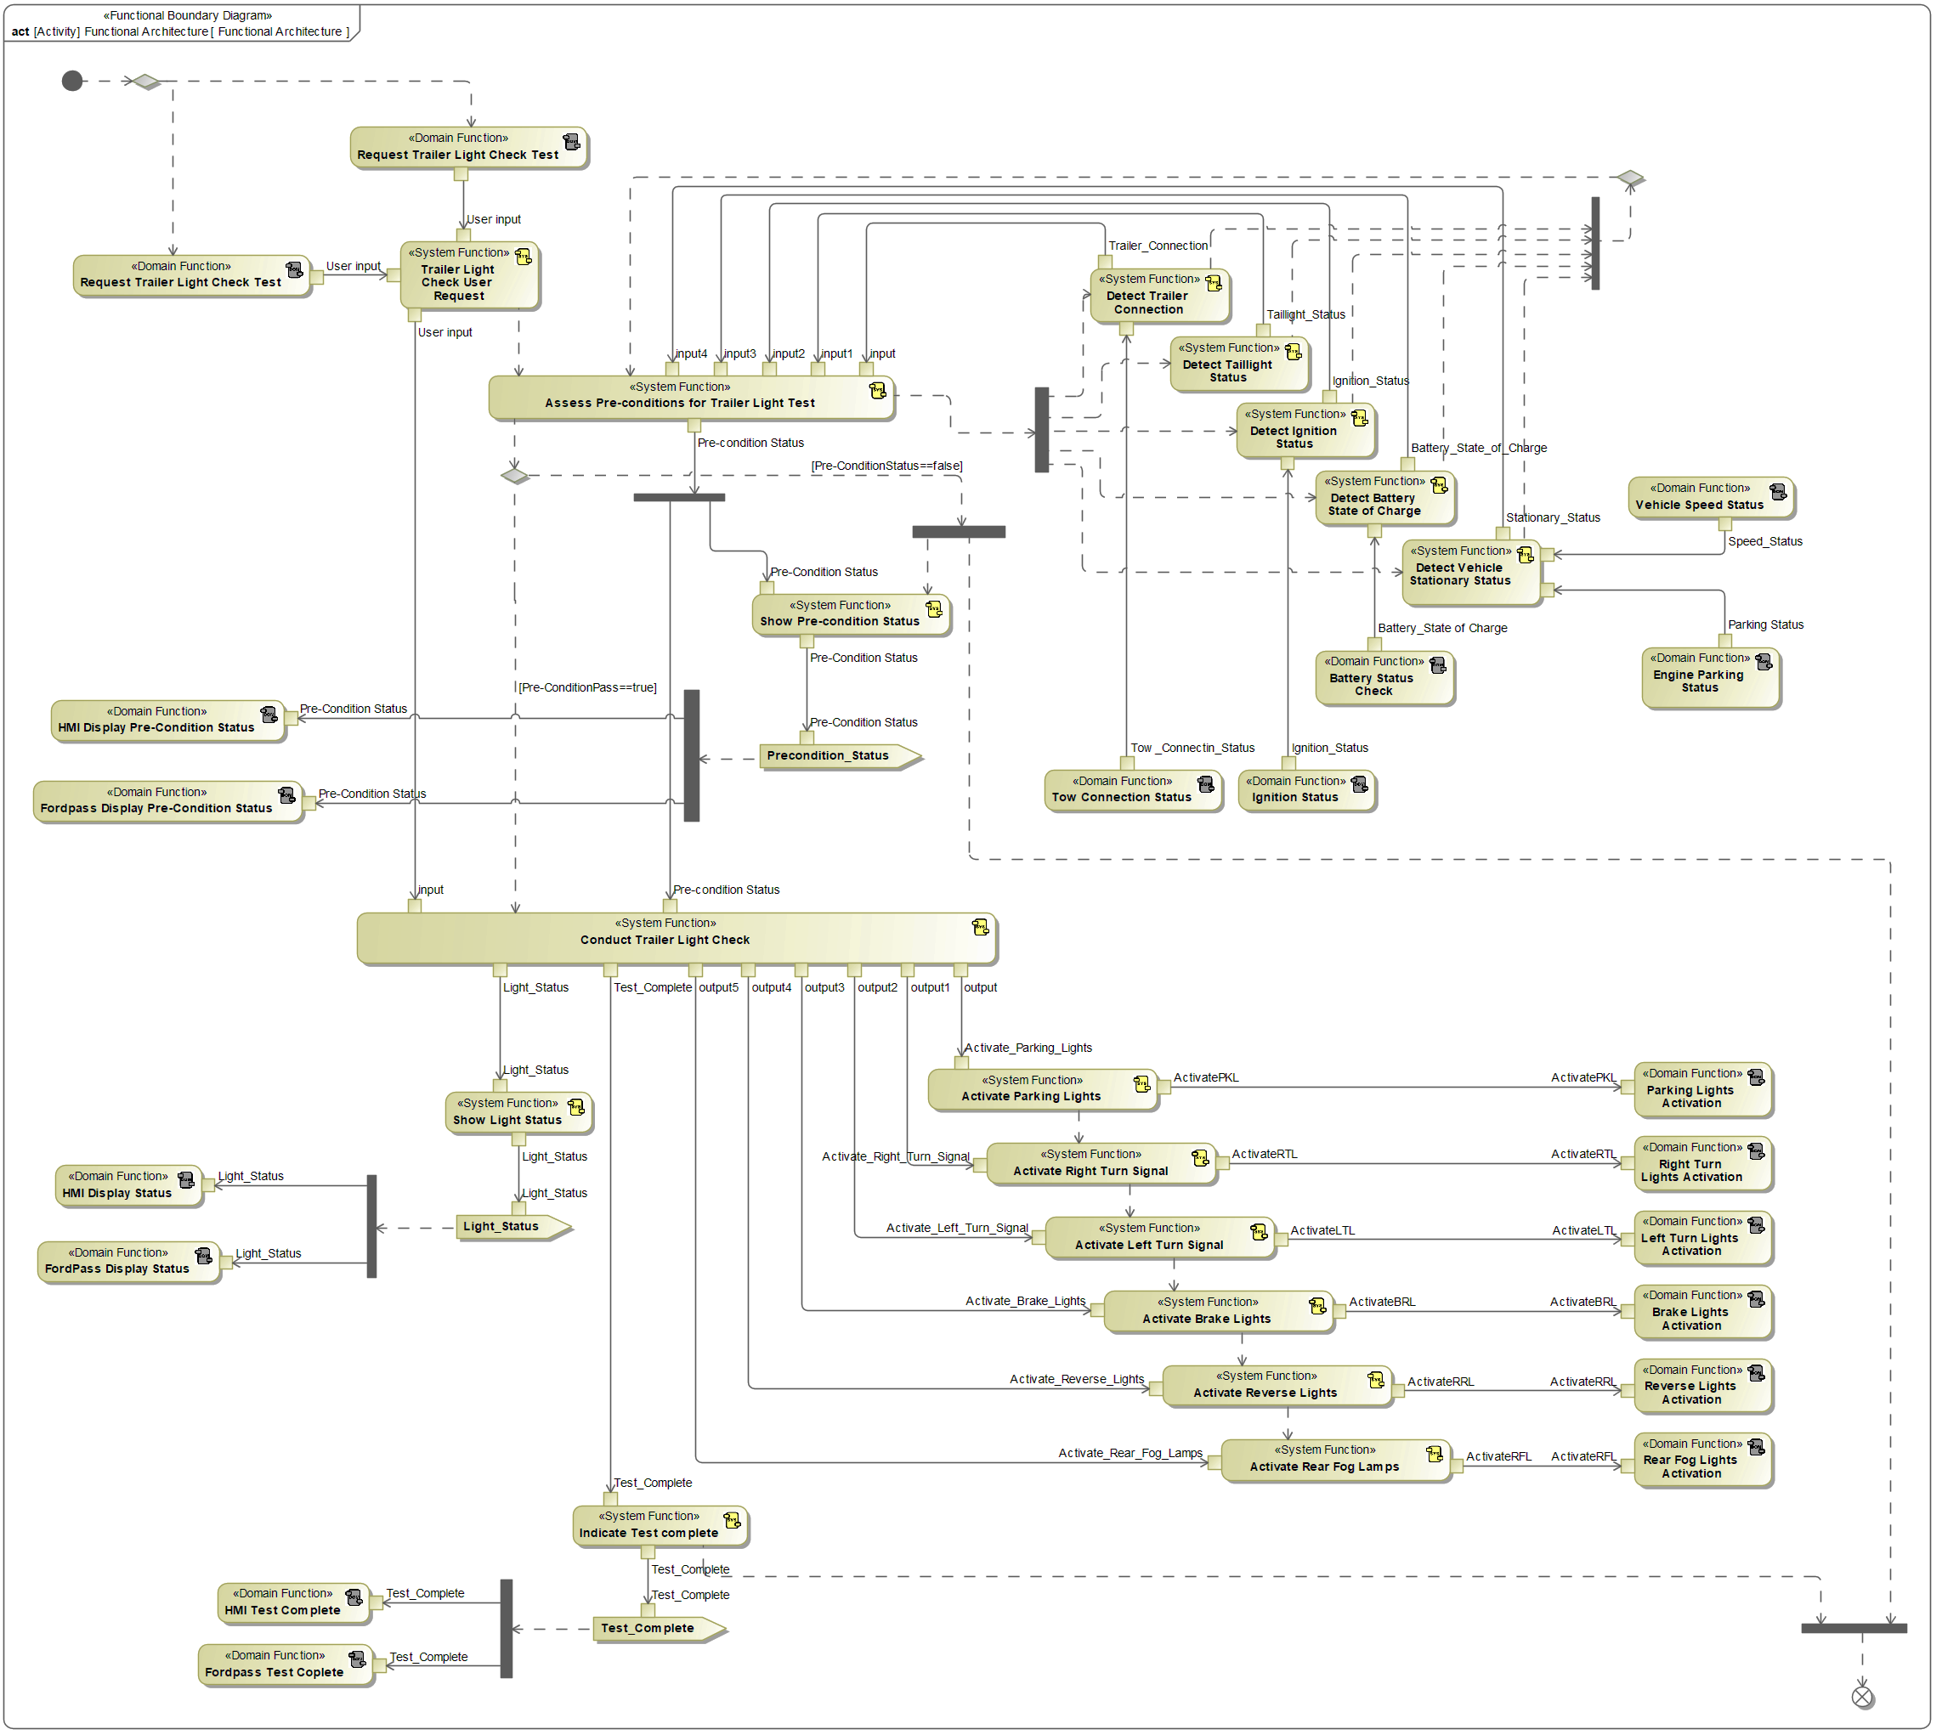

**Figure 6: Functional Architecture**

### List of Functions

|  |  |  |  |
| --- | --- | --- | --- |
| Function Name | Description | Link to Function Spec | Comments |
| Detect Ignition Status | Ignition status determination for feature pre-condition assessment | N/A | Existing function |
| Detect Taillight Status | Taillight status determination for feature pre-condition assessment | N/A | Existing function |
| Detect Battery State of Charge | Vehicle battery state of charge determination for feature pre-condition assessment | N/A | Existing function |
| Activate Tail Lights | Illuminate tail lights on vehicle and trailer | N/A | Existing function |
| Activate Right Turn Signal | Illuminate right turn signal lights on vehicle and trailer | N/A | Existing function |
| Activate Left Turn Signal | Illuminate Left turn signal lights on vehicle and trailer | N/A | Existing function |
| Activate Brake Lights | Illuminate brake lights on vehicle and trailer | N/A | Existing function |
| Activate Reverse Lights | Illuminate reverse lights on vehicle and trailer | N/A | Existing function |
| Activate Rear Fog Lights | Illuminate rear fog lights on vehicle and trailer | N/A | Existing function |
| Trailer Light Check User Request | Sends user request to initiate or end test to conduct Trailer Light Check function | [VSEM Link](https://www.vsemweb.ford.com/tc/launchapp?-attach=true&-s=226TCSession&-o=CKaxDdlMx3NrTDAAAAAAAAAAAAA&servername=Production_Server) | New function |
| Detect Vehicle Stationary Status | Vehicle stationary status determination for feature pre-condition assessment | [VSEM Link](https://www.vsemweb.ford.com/tc/launchapp?-attach=true&-s=226TCSession&-o=CKaxDdlMx3NrTDAAAAAAAAAAAAA&servername=Production_Server) | New function |
| Assess Pre-conditions for Trailer Light Check | Evaluates pre-conditions for enabling Trailer Light Check feature. Receives ignition status, battery SOC, vehicle stationary status, and exterior light status. Sends out pre-condition status message | [VSEM Link](https://www.vsemweb.ford.com/tc/launchapp?-attach=true&-s=226TCSession&-o=CKaxDdlMx3NrTDAAAAAAAAAAAAA&servername=Production_Server) | New function |
| Conduct Trailer Light Check | Illuminates exterior lights in feature determined sequence and sends test complete message | [VSEM Link](https://www.vsemweb.ford.com/tc/launchapp?-attach=true&-s=226TCSession&-o=CKaxDdlMx3NrTDAAAAAAAAAAAAA&servername=Production_Server) | New function |
| Show Pre-condition Status | Displays pre-condition status on UI if pre-conditions are not met | [VSEM Link](https://www.vsemweb.ford.com/tc/launchapp?-attach=true&-s=226TCSession&-o=CKaxDdlMx3NrTDAAAAAAAAAAAAA&servername=Production_Server) | New function |
| Indicate Test Complete | Displays test complete or test ended (if user requests test cancellation) notification on UI | [VSEM Link](https://www.vsemweb.ford.com/tc/launchapp?-attach=true&-s=226TCSession&-o=CKaxDdlMx3NrTDAAAAAAAAAAAAA&servername=Production_Server) | New function |
| Trailer Light Check HMI Display | User HMI that allows interaction with the Trailer Light Check feature | [VSEM Link](https://www.vsemweb.ford.com/tc/launchapp?-attach=true&-s=226TCSession&-o=CKaxDdlMx3NrTDAAAAAAAAAAAAA&servername=Production_Server) | New function |

Table 15: List of Functions

## Logical Architecture

Description of diagram and content on logical architecture in Documentation field of Structural Boundary Diagram.

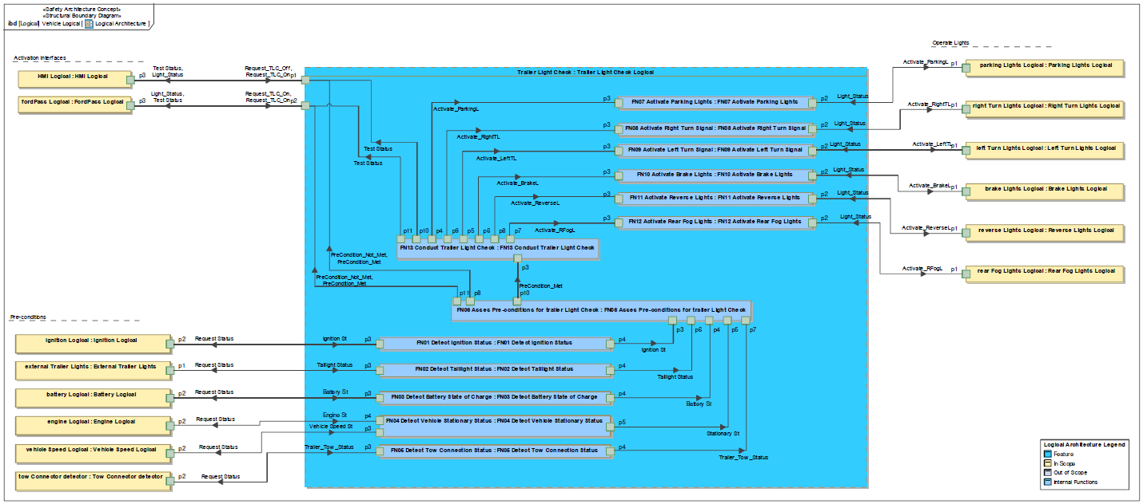

Figure 8: Logical Architecture

### Logical Elements

|  |  |  |
| --- | --- | --- |
| **Element Name** | **Description** | **Allocated Functions** |
| Battery Logical | Check the status of battery | * Battery Status Check * Detect Battery State of Charge |
| Brake Lights Logical | Check the status of brake | * Activate Brake Lights * Brake Lights Activation |
| Engine Logical | Check the status of engine | * Detect Vehicle Stationary Status * Engine Parking Status |
| External Trailer Lights | Check Taillight status | * Detect Taillight Status |
| FN01 Detect Ignition Status | Check Ignition status | * Detect Ignition Status |
| FN02 Detect Taillight Status | Check Taillight status | * Detect Tailight Status |
| FN03 Detect Battery State of Charge | Check Battery status | * Detect Battery State of Charge |
| FN04 Detect Vehicle Stationary Status | Check Vehicle status | * Detect Vehicle Sationary Status |
| FN05 Detect Tow Connection Status | Check Tow Connection status | * Detect Tow Conection Status |
| FN06 Asses Pre-conditions for trailer Light Check | Check all pre-conditions for run Trailer Light Check | * Assess Pre-conditions for Trailer Light Test |
| FN07 Activate Parking Lights | Activated Parking Lights according sequence | * Activate Parking Lights |
| FN08 Activate Right Turn Signal | Activated Right Lights according sequence | * Activate Right Turn Signal |
| FN09 Activate Left Turn Signal | Activated Left Lights according sequence | * Activate Left Turn Signal |
| FN10 Activate Brake Lights | Activated Brake Lights according sequence | * Activate Brake Lights |
| FN11 Activate Reverse Lights | Activated Reverse Lights according sequence | * Activate Reverse Lights |
| FN12 Activate Rear Fog Lights | Activated Rear Fog Lights according sequence | * Activate Rear Fog Lamps |
| FN13 Conduct Trailer Light Check | Conduct the Trailer Light Check Sequence | * Conduct Trailer Light Check |
| FordPass Logical | Trailer Light Check process at FordPass app | * Fordpass Display Pre-Condition Status * FordPass Display Status * Fordpass Test Complete * Indicate Test complete * Request Trailer Light Check Test * Show Pre-condition Status |
| HMI Logical | Trailer Light Check process at Sync | * HMI Display Pre-Condition Status * HMI Display Status * HMI Test Complete * Indicate Test complete * Request Trailer Light Check Test * Show Pre-condition Status |
| Ignition Logical | Ignition status information | * Ignition Status |
| Left Turn Lights Logical | Activated/Deactivated Left Lights according sequence | * Activate Left Turn Signal * Left Turn Lights Activation |
| Parking Lights Logical | Activated/Deactivated Parking Lights according sequence | * Activate Parking Lights * Parking Lights Activation |
| Rear Fog Lights Logical | Activated/Deactivated Fog Lights Lights according sequence | * Activate Rear Fog Lamps * Rear Fog Lights Activation |
| Reverse Lights Logical | Activated/Deactivated Reverse Lights according sequence | * Activate Reverse Lights * Reverse Lights Activation |
| Right Turn Lights Logical | Activated/Deactivated Right Lights according sequence | * Activate Right Turn Signal * Right Turn Lights Activation |
| Tow Connector detector | Tow connector status information | * Detect Trailer Connection * Tow Connection Status |
| Trailer Light Check Logical | Trailer Light Check process | * Activate Brake Lights * Activate Left Turn Signal * Activate Parking Lights * Activate Rear Fog Lamps * Activate Reverse Lights * Activate Right Turn Signal * Assess Pre-conditions for Trailer Light Test * Conduct Trailer Light Check * Detect Battery State of Charge * Detect Ignition Status * Detect Taillight Status * Detect Trailer Connection * Detect Vehicle Stationary Status * Indicate Test complete * Show Light Status * Show Pre-condition Status * Trailer Light Check User Request |
| Vehicle Speed Logical | Vechicle speed status information | * Detect Vehicle Stationary Status * Vehicle Speed Status |

Table 16: Logical Elements

### Logical Interfaces

|  |  |  |  |
| --- | --- | --- | --- |
| **Interface** | **Direction** | **Description** | **Value Range** |
| Activate_BrakeL | p2 (FN10 Activate Brake Lights) To p1 (Brake Lights Logical) | TLightt_STP_Stat  BCM to ITRM/TRM(ECG Passthrough) | 0x0 Off  0x1 On |
| p6 (FN13 Conduct Trailer Light Check) To p3 (FN10 Activate Brake Lights) |
| Activate_LeftTL | p2 (FN09 Activate Left Turn Signal) To p1 (Left Turn Lights Logical) | TurnLghtLeft_D_Rq  BCM to ITRM/TRM(ECG Passthrough) | 0x0 Null (Defaulted)  0x1 Off  0x2 On  0x3 error |
| p5 (FN13 Conduct Trailer Light Check) To p3 (FN09 Activate Left Turn Signal) |
| Activate_ParkingL | p2 (FN07 Activate Parking Lights) To p1 (Parking Lights Logical) | Parklamp_Status  BCM to ITRM/TRM(ECG Passthrough) | 0x0 Null (Defaulted)  0x1 Off  0x2 On  0x3 error |
| p4 (FN13 Conduct Trailer Light Check) To p3 (FN07 Activate Parking Lights) |
| Activate_ReverseL | p2 (FN11 Activate Reverse Lights) To p1 (Reverse Lights Logical) | RvrseLghtOn_B_Stat | 0x0 Off  0x1 On |
| p8 (FN13 Conduct Trailer Light Check) To p3 (FN11 Activate Reverse Lights) |
| Activate_RFogL | p2 (FN12 Activate Rear Fog Lights) To p1 (Rear Fog Lights Logical) | FogLghtRearOn_B_Stat | 0x0 Off  0x1 On |
| p7 (FN13 Conduct Trailer Light Check) To p3 (FN12 Activate Rear Fog Lights) |
| Activate_RightTL | p2 (FN08 Activate Right Turn Signal) To p1 (Right Turn Lights Logical) | TurnLghtRight_D_Rq  BCM to ITRM/TRM(ECG Passthrough) | 0x0 Null (Defaulted)  0x1 Off  0x2 On  0x3 error |
| p9 (FN13 Conduct Trailer Light Check) To p3 (FN08 Activate Right Turn Signal) |
| Battery St | p2 (Battery Logical) To p3 (FN03 Detect Battery State of Charge) | TlghtTestPrecnd_D_Stat  (MY21.00 P702 & U725)  TlghtTestPrecnd_D2_Stat  (MY21.50 P702 & MY22.00 onwards) | 0x0 Null  0x1 Ignition not ON  0x2 Taillights ON  0x3 Battery SOC < 75% with battery not supported  0x4 PreconditionsPassed  0x5 InteractionPresent  0x6 Not stationary  0x7 Error  0x0 Null  0x1 IgnitionNotOn  0x2 TailLightsOn  0x3 BattSocLessThan75Percent  0x4 PreconditionsPassed  0x5 InteractionPresent  0x6 NotStationary  0x7 TrailerNotConnected |
| p4 (FN03 Detect Battery State of Charge) To p4 (FN06 Asses Pre-conditions for trailer Light Check) |
| Engine St | p2 (Engine Logical) To p4 (FN04 Detect Vehicle Stationary Status) | TlghtTestPrecnd_D_Stat  (MY21.00 P702 & U725)  TlghtTestPrecnd_D2_Stat  (MY21.50 P702 & MY22.00 onwards) | 0x0 Null  0x1 Ignition not ON  0x2 Taillights ON  0x3 Battery SOC < 75% with battery not supported  0x4 PreconditionsPassed  0x5 InteractionPresent  0x6 Not stationary  0x7 Error  0x0 Null  0x1 IgnitionNotOn  0x2 TailLightsOn  0x3 BattSocLessThan75Percent  0x4 PreconditionsPassed  0x5 InteractionPresent  0x6 NotStationary  0x7 TrailerNotConnected |
| Ignition St | p2 (Ignition Logical) To p3 (FN01 Detect Ignition Status) | TlghtTestPrecnd_D_Stat  (MY21.00 P702 & U725)  TlghtTestPrecnd_D2_Stat  (MY21.50 P702 & MY22.00 onwards) | 0x0 Null  0x1 Ignition not ON  0x2 Taillights ON  0x3 Battery SOC < 75% with battery not supported  0x4 PreconditionsPassed  0x5 InteractionPresent  0x6 Not stationary  0x7 Error  0x0 Null  0x1 IgnitionNotOn  0x2 TailLightsOn  0x3 BattSocLessThan75Percent  0x4 PreconditionsPassed  0x5 InteractionPresent  0x6 NotStationary  0x7 TrailerNotConnected |
| p4 (FN01 Detect Ignition Status) To p3 (FN06 Asses Pre-conditions for trailer Light Check) |
| Light_Status | p1 (Brake Lights Logical) To p2 (FN10 Activate Brake Lights) | TLightt_STP_Stat  BCM to ITRM/TRM(ECG Passthrough) | 0x0 Off  0x1 On |
| p1 (Left Turn Lights Logical) To p2 (FN09 Activate Left Turn Signal) | TurnLghtLeft_D_Rq  BCM to ITRM/TRM(ECG Passthrough) | 0x0 Null (Defaulted)  0x1 Off  0x2 On  0x3 error |
| p1 (Parking Lights Logical) To p2 (FN07 Activate Parking Lights) | Parklamp_Status  BCM to ITRM/TRM(ECG Passthrough) | 0x0 Null (Defaulted)  0x1 Off  0x2 On  0x3 error |
| p1 (Rear Fog Lights Logical) To p2 (FN12 Activate Rear Fog Lights) | FogLghtRearOn_B_Stat | 0x0 Off  0x1 On |
| p1 (Reverse Lights Logical) To p2 (FN11 Activate Reverse Lights) | RvrseLghtOn_B_Stat | 0x0 Off  0x1 On |
| p1 (Right Turn Lights Logical) To p2 (FN08 Activate Right Turn Signal) | TurnLghtRight_D_Rq  BCM to ITRM/TRM(ECG Passthrough) | 0x0 Null (Defaulted)  0x1 Off  0x2 On  0x3 error |
| p1 (Trailer Light Check Logical) To p3 (HMI Logical) | TlghtTest_D_RqArb | 0x0 Null (Defaulted)  0x1 Stop Test  0x2 Start Test  0x3 Test end ack |
| p2 (Trailer Light Check Logical) To p3 (FordPass Logical) | TlghtTest_D_RqArb | 0x0 Null (Defaulted)  0x1 Stop Test  0x2 Start Test  0x3 Test end ack |
| PreCondition_Met | p8 (FN06 Asses Pre-conditions for trailer Light Check) To p1 (Trailer Light Check Logical) | TlghtTestPrecnd_D_Stat  (MY21.00 P702 & U725)  TlghtTestPrecnd_D2_Stat  (MY21.50 P702 & MY22.00 onwards) | 0x0 Null  0x1 Ignition not ON  0x2 Taillights ON  0x3 Battery SOC < 75% with battery not supported  0x4 PreconditionsPassed  0x5 InteractionPresent  0x6 Not stationary  0x7 Error  0x0 Null  0x1 IgnitionNotOn  0x2 TailLightsOn  0x3 BattSocLessThan75Percent  0x4 PreconditionsPassed  0x5 InteractionPresent  0x6 NotStationary  0x7 TrailerNotConnected |
| p10 (FN06 Asses Pre-conditions for trailer Light Check) To p3 (FN13 Conduct Trailer Light Check) |
| p11 (FN06 Asses Pre-conditions for trailer Light Check) To p2 (Trailer Light Check Logical) |
| PreCondition_Not_Met | p8 (FN06 Asses Pre-conditions for trailer Light Check) To p1 (Trailer Light Check Logical) | TlghtTestPrecnd_D_Stat  (MY21.00 P702 & U725)  TlghtTestPrecnd_D2_Stat  (MY21.50 P702 & MY22.00 onwards) | 0x0 Null  0x1 Ignition not ON  0x2 Taillights ON  0x3 Battery SOC < 75% with battery not supported  0x4 PreconditionsPassed  0x5 InteractionPresent  0x6 Not stationary  0x7 Error  0x0 Null  0x1 IgnitionNotOn  0x2 TailLightsOn  0x3 BattSocLessThan75Percent  0x4 PreconditionsPassed  0x5 InteractionPresent  0x6 NotStationary  0x7 TrailerNotConnected |
| p11 (FN06 Asses Pre-conditions for trailer Light Check) To p2 (Trailer Light Check Logical) |
| Request Status | p3 (FN01 Detect Ignition Status) To p2 (Ignition Logical) | TlghtTestPrecnd_D_Stat  (MY21.00 P702 & U725)  TlghtTestPrecnd_D2_Stat  (MY21.50 P702 & MY22.00 onwards) | 0x0 Null  0x1 Ignition not ON  0x2 Taillights ON  0x3 Battery SOC < 75% with battery not supported  0x4 PreconditionsPassed  0x5 InteractionPresent  0x6 Not stationary  0x7 Error  0x0 Null  0x1 IgnitionNotOn  0x2 TailLightsOn  0x3 BattSocLessThan75Percent  0x4 PreconditionsPassed  0x5 InteractionPresent  0x6 NotStationary  0x7 TrailerNotConnected |
| p3 (FN02 Detect Taillight Status) To p1 (External Trailer Lights) |
| p3 (FN03 Detect Battery State of Charge) To p2 (Battery Logical) |
| p3 (FN04 Detect Vehicle Stationary Status) To p2 (Vehicle Speed Logical) |
| p3 (FN05 Detect Tow Connection Status) To p2 (Tow Connector detector) |
| p4 (FN04 Detect Vehicle Stationary Status) To p2 (Engine Logical) |
| Request_TLC_Off | p3 (HMI Logical) To p1 (Trailer Light Check Logical) | TlghtTest_D_Stat  TlghtTestLght_D_Stat  (MY21.00 P702 & U725) | 0x0 Null (Defaulted)  0x1 Test completed  0x2 Test ended  0x3 Test in progress  0x0 Null (Defaulted)  0x1 Parking/position lights illuminated  0x2 Testing right turn signal  0x3 Testing left turn signal  0x4 Testing brake lights  0x5 Testing reverse lights  0x6 All off  0x7 Error |
| Request_TLC_On | p3 (FordPass Logical) To p2 (Trailer Light Check Logical) |
| p3 (HMI Logical) To p1 (Trailer Light Check Logical) |
| Stationary St | p5 (FN04 Detect Vehicle Stationary Status) To p5 (FN06 Asses Pre-conditions for trailer Light Check) | TlghtTestPrecnd_D_Stat  (MY21.00 P702 & U725)  TlghtTestPrecnd_D2_Stat  (MY21.50 P702 & MY22.00 onwards) | 0x0 Null  0x1 Ignition not ON  0x2 Taillights ON  0x3 Battery SOC < 75% with battery not supported  0x4 PreconditionsPassed  0x5 InteractionPresent  0x6 Not stationary  0x7 Error  0x0 Null  0x1 IgnitionNotOn  0x2 TailLightsOn  0x3 BattSocLessThan75Percent  0x4 PreconditionsPassed  0x5 InteractionPresent  0x6 NotStationary  0x7 TrailerNotConnected |
| Taillight Status | p1 (External Trailer Lights) To p3 (FN02 Detect Taillight Status) | TlghtTest_D_Stat  TlghtTestLght_D_Stat  (MY21.00 P702 & U725) | 0x0 Null (Defaulted)  0x1 Test completed  0x2 Test ended  0x3 Test in progress  0x0 Null (Defaulted)  0x1 Parking/position lights illuminated  0x2 Testing right turn signal  0x3 Testing left turn signal  0x4 Testing brake lights  0x5 Testing reverse lights  0x6 All off  0x7 Error |
| p4 (FN02 Detect Taillight Status) To p6 (FN06 Asses Pre-conditions for trailer Light Check) |
| Test Status | p1 (Trailer Light Check Logical) To p3 (HMI Logical) | TlghtTest_D_Stat  TlghtTestLght_D_Stat  (MY21.00 P702 & U725) | 0x0 Null (Defaulted)  0x1 Test completed  0x2 Test ended  0x3 Test in progress  0x0 Null (Defaulted)  0x1 Parking/position lights illuminated  0x2 Testing right turn signal  0x3 Testing left turn signal  0x4 Testing brake lights  0x5 Testing reverse lights  0x6 All off  0x7 Error |
| p2 (Trailer Light Check Logical) To p3 (FordPass Logical) |
| p10 (FN13 Conduct Trailer Light Check) To p1 (Trailer Light Check Logical) |
| p11 (FN13 Conduct Trailer Light Check) To p2 (Trailer Light Check Logical) |
| Trailer_Tow_Status | p2 (Tow Connector detector) To p3 (FN05 Detect Tow Connection Status) | TlghtTestPrecnd_D_Stat  (MY21.00 P702 & U725)  TlghtTestPrecnd_D2_Stat  (MY21.50 P702 & MY22.00 onwards) | 0x0 Null  0x1 Ignition not ON  0x2 Taillights ON  0x3 Battery SOC < 75% with battery not supported  0x4 PreconditionsPassed  0x5 InteractionPresent  0x6 Not stationary  0x7 Error  0x0 Null  0x1 IgnitionNotOn  0x2 TailLightsOn  0x3 BattSocLessThan75Percent  0x4 PreconditionsPassed  0x5 InteractionPresent  0x6 NotStationary  0x7 TrailerNotConnected |
| p4 (FN05 Detect Tow Connection Status) To p7 (FN06 Asses Pre-conditions for trailer Light Check) |
| Vehicle Speed St | p2 (Vehicle Speed Logical) To p3 (FN04 Detect Vehicle Stationary Status) | TlghtTestPrecnd_D_Stat  (MY21.00 P702 & U725)  TlghtTestPrecnd_D2_Stat  (MY21.50 P702 & MY22.00 onwards) | 0x0 Null  0x1 Ignition not ON  0x2 Taillights ON  0x3 Battery SOC < 75% with battery not supported  0x4 PreconditionsPassed  0x5 InteractionPresent  0x6 Not stationary  0x7 Error  0x0 Null  0x1 IgnitionNotOn  0x2 TailLightsOn  0x3 BattSocLessThan75Percent  0x4 PreconditionsPassed  0x5 InteractionPresent  0x6 NotStationary  0x7 TrailerNotConnected |
| p3 (FN04 Detect Vehicle Stationary Status) To p2 (Vehicle Speed Logical) |

Table 17: Feature Interactions

# Open Concerns

| ID | Concern Description | e-Tracker / Reference | Responsible | Status | Solution |
| --- | --- | --- | --- | --- | --- |
| 1 | N/A | N/A | N/A | N/A | N/A |

Table 18: Open Concerns

# Revision History

|  |  |  |  |  |
| --- | --- | --- | --- | --- |
| Revision | Date | Description | Approved by | Responsible |
| 001 | 04/29/2021 | Initial release uploaded to VSEM |  | abatis38 |

Table 19: Revision History

## Template Revisions

*#Important: Do not change this section*

|  |  |  |  |  |
| --- | --- | --- | --- | --- |
| Version | Rev. | Date | Description | Responsible |
| *0* | *6* | *2015-05-26* | * *Chapter “Feature Overview” and made a 2nd level heading.* * *Chapter “Feature Modeling” divided into 3 subchapter (“Scenarios”, “Use Cases”, “State Machines”) for different modeling methods* | *Jbaden1* |
| *0* | *7* | *2015-05-27* | * *Table of Content updated* * *Template Revision History chapter added* | *Jbaden1* |
| *0* | *8* | *2015-07-02* | * *Section “Unsettled Issues” added* | *Alevin7* |
| *0* | *9* | *2015-08-04* | * *Section “Feature Variants” added* * *Section “Feature Boundary Diagram” renamed to “Feature Context Diagram”* * *Document Properties adapted to match needs of VBA macros* | *Jbaden1, Awegman1* |
| *1* | *0* | *2015-09-11* | * *Section “Feature Variants” reworked* * *Feature Goals removed. Only “Safety Goals“ chapter remains.* * *Heading 2 formatting issues corrected.* * *Requirements / Use Cases Listing removed from traceability chapter.* * *Formatting of attribute table in Notation chapter corrected* * *Open Topics / Known Issues chapter moved to the end* | *Jbaden1* |
| *1* | *1* | *2015-11-16* | * *Table-Styles removed (for smooth VSEM import)* * *Some clean-up of sections “Purpose” and “Audience”* | *Awegman1, jbaden1* |
| *1* | *2* | *2016-02-26* | * *Minor corrections based on lessons learned from CC and PCL pilot (e.g. section market/regions) and discussion with Functional Safety Team (purpose of feature)* * *Footer corrected* * *Boundary diagram interface chapter renamed to influences.* | *Jbaden1* |
| *1* | *3* | *2016-02-26* | * *Minor corrections after review with Whitney Keith from Functional Safety team* | *Jbaden1* |
| *1* | *4* | *2016-03-10* | * *Some cleanup of meta-data in Word Properties* | *Jbaden1* |
| *1* | *5* | *2016-03-10* | * *Footer formatting corrected (Issue 19)* * *Results from review with Functional Safety Team incorporated (Issue 20).* | *jbaden1* |
| *1* | *6* | *2016-04-18* | * *Scenario Template added* | *Jbaden1* |
| *1* | *7* | *2016-04-18* | * *Chapter “Operation Modes and States” moved before “Use Case” section.* | *Jbaden1* |
| *1* | *8* | *2016-04-18* | * *Broken Wiki links repaired.* | *Jbaden1* |
| *2* | *0* | *2016-05-19* | * *Adapted to Specification_Macros.dotm V2.0* * *Requirements Templates chapter (ch. 1.7.1) no longer has an attribute table, but refers directly to the Wiki..* | *Jbaden1* |
| *2* | *1* | *2016-06-10* | * *Table for Context Diagram modified (lists external entities and Influence Description only)* | *Jbaden1* |
| *2* | *2* | *2016-07-08* | * *Template version added to footer* * *Several hints added to the various sections* * *Findings from Functional Safety Team incorporated.* * *RE_SafetyRequirement style added* | *Jbaden1* |
| *2* | *3* | *2016-09-21* | * *Update from Functional Safety Team incorporated (“Lessons Learned”, “System Behaviors for HARA”)* | *Jbaden1* |
| *2* | *4* | *2016-11-15* | * *Update from Functional Safety Team incorporated (“Lessons Learned”, “System Behaviors for HARA”)* * *Explanatory notes made more formal* | *Jbaden1* |
| *3* |  |  | *Skipped to synchronize with Specification_Macros.dotm* |  |
| *4* |  |
| *5* | *0* | *2017-01-13* | * *Meta data updated for specification macros, version 3.1* * *SW Unit chapter removed for the time being* * *Green boxes added for user hints* | *Jbaden1* |
| *5* | *1* | *2017-01-18* | * *Minor editorial changes* | *Jbaden1* |
| *6* | *0* | *2017-02-03* | * *CR48: Chapter 6 renamed from “Safety” to “Functional Safety”. New sub-chapter “Safety” introduced in Non-Functional Requirements section* | *Jbaden1* |
| *6* | *0* | *2017-04-28* | * *CR7: “RequirementsTraceability” chapter removed* | *Jbaden1* |
| *6* | *0* | *2017-11-15* | * *CR32/53: New Cover Sheet + Disclaimer replaces FAP-150 like ones.* * *CR75: Some rewording -> Terminology to Glossary, Notation -> Document Conventions* * *CR49: Rename “Assumptions & Constraints” to “Assumptions”* * *CR74: Safety Assumptions added to chapter 6.* * *CR58: Add function allocation column to Logical Architecture chapter* | *Jbaden1* |
| *6* | *0* | *2018-01-31* | * *CR63: Updated links to Functional Safety Sharepoint* | *Jbaden1* |
| *6* | *0* | *2018-07-24* | * *CR69: Add FSR to FeatureDoc* * *CR64: Add new section "Design Requirements" to Function Spec and Feature Spec* | *Jbaden1* |
| *6* | *0* | *2018-08-06* | * *CR53: some corrections for metada and formatting* | *Jbaden1* |
| *6* | *0* | *2018-09-28* | * *Broken links to RE Wiki repaired* | *Jbaden1* |
| *6* | *0* | *2018-10-31* | * *Cover sheet and footer more GIS like. Functional Safety team feedback incorporated:*   + *New subsections “Functional Safety Requirements, (Decomposed) FSRs and Parameters / Values*   + *Removal of “Logical Architecture”* | *Jbaden1* |
| *6* | *0* | *2018-12-12* | * *FSR template removed, now as a macro in the Specification_Macros.dotm* | *Jbaden1* |
| *N* |  | *2019-04-03* | * *Updated code for context diagrams, actors and use cases.* * *Updated code structure with all macros at the beginning.* * *Updated code to populate assumptions using element-assumption relationship or hazardous event.* | *snuesch* |
| *N* |  | *2019-04-18* | * *Added structural boundary diagram for FuSa based on TGB discussion.* * *Added operating modes to functional safety requirements.* | *snuesch* |
| *N* |  | *2019-04-25* | * *Improved export of actions and activities on functional boundary diagram.* | *snuesch* |
| *6* | *0b* | *2019-05-23* | * *Re-introduce “Logical Architecture” (for Functional Safety)* | *Jbaden1* |
| *N* |  | *2019-06-17* | * *Aligned “Architecture” section with RE template.* * *Made “Ford Documents” table more flexible.* * *Added template terms to glossary* | *snuesch* |
| *N* |  | *2019-06-25* | * *Improved use cases to handle Primary and Secondary actors.* * *Added Performance Requirements to Uncategorized.* | *snuesch* |
| *6* | *0b* | *2019-06-26* | * *Chapter “Logical Elements” in “Logical Architecture” section added (FuSa CR 15136240)* * *“References” and “Glossary” chapter moved from section “Feature Overview” to “Introduction”. References and Glossary should be available in the document as early as possible* | *Jbaden1* |
| *N* |  | *2019-07-25* | * *Added populated “Logical Elements” table and allocated functions.* * *Export documentation field of context diagram.* | *snuesch* |
| *N* |  | *2019-08-09* | * *Export documentation field of use case diagram.* * *Fixed bug in Feature Requirement Verification Method.* * *Simplified export of References without publisher.* | *snuesch* |
| *N* |  | *2019-08-21* | * *Improved glossary and acronym tables* | *snuesch* |
| *N* |  | *2019-08-28* | * *Fixed bug in populating title in header* | *snuesch* |
| *N* |  | *2019-09-16* | * *Updated bibliography export* | *snuesch* |
| *N* |  | *2019-09-27* | * *Updated export of Verification Method and Requirement Status for Feature Requirements and V&V Method for Functional Safety Requirements.* | *snuesch* |
| *O* |  | *2019-11-12* | * *Updated bibliography export to include URL.* * *Allow hardware element on context diagram.* * *labelTag variable can be used to filter revision history.* * *Added logical property element type to beplled in from structural boundary diagram.* | *snuesch* |

# Appendix

## Definitions

| **Definition** | **Description** |
| --- | --- |
| APIM | Application Protocol Interface Module |
| FTTI | Fault Tolerance Time Interval |
| ITRM | Integrated Trailer Module |
| SOC | State Of Charge |
| UI | User Interface |

Table 20: Definitions used in this document

## Abbreviations

No acronyms specified.

Document ends here.